Eclipse Preparation TIPS for Local Resident

Miami County will experience a total solar eclipse when the moon passes between the Sun and Earth on Monday, April 8th 2024 between 1:53pm and 4:25pm. We will be completely in the path of totality for 3 minutes and 45 seconds with maximum totality at 3:11pm.
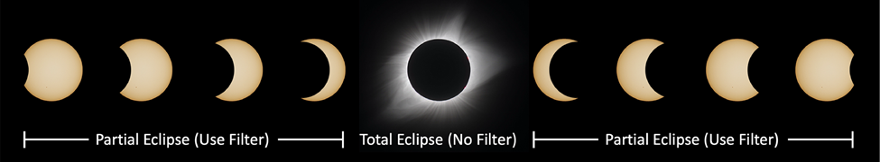
Safety:
The only safe way to look directly at the uneclipsed or partially eclipsed Sun is through special-purpose solar filters, such as “eclipse glasses” or hand-held viewers that meet the ISO 12312-2 international standard. Homemade filters or ordinary sunglasses, even very dark ones, are not safe for looking at the Sun. Go to the American Astronomical Society webpage for approved filters: https://eclipse.aas.org/resources/solar-filters.
DO NOT look at the uneclipsed or partially eclipsed Sun with the naked eye or through unfiltered camera, telescope, binoculars, or other optical device. DO NOT look at the Sun through an optical device while using eclipse glasses or viewers – the concentrated solar rays will damage the filter and enter your eyes causing serious and potentially permanent injury.
Things to Consider:
Miami County expects a significant increase in visitors to the area between Friday, April 5th and Tuesday, April 9th 2024. Traffic will be heavy and lines may be long for local services such as restaurants, gas stations, grocery, and retail stores. Do what you can ahead of time and allow extra time to get where you need to go.
- Errands and Appointments: Schedule important activities before Friday, April 5th or after Tuesday, April 9th Check ahead if you have plans for Monday, April 8th; some services may be closed or have limited hours. By scheduling early, you will beat the crowds and give our local stores and businesses time to restock before the eclipse visitors arrive; this includes grocery shopping, doctor/dentist/veterinary appointments, prescriptions, etc.
- Supplies, Gas, Cash: Supplies may be limited due to high demand which may mean the things you want are not available during the congested period. If there is something important you need, get it early.
- 911: Know when it is appropriate to call 911 (true emergencies). If not a true emergency, use the non-emergency number to contact the County Dispatch Center at (937) 440-9911.
- Cellular Service: With the increased number of visitors, anticipate cellular service may be overwhelmed (primarily Monday the 8th). Develop a communication plan with family and friends if you lose service. If you have only a mobile phone at home, find out which neighbors have a land-line number in case you need to call 911 for an emergency.

For more information:
https://www.miamicountysolareclipse.com/
https://ema.ohio.gov/media-publications/ohio-total-solar-eclipse

